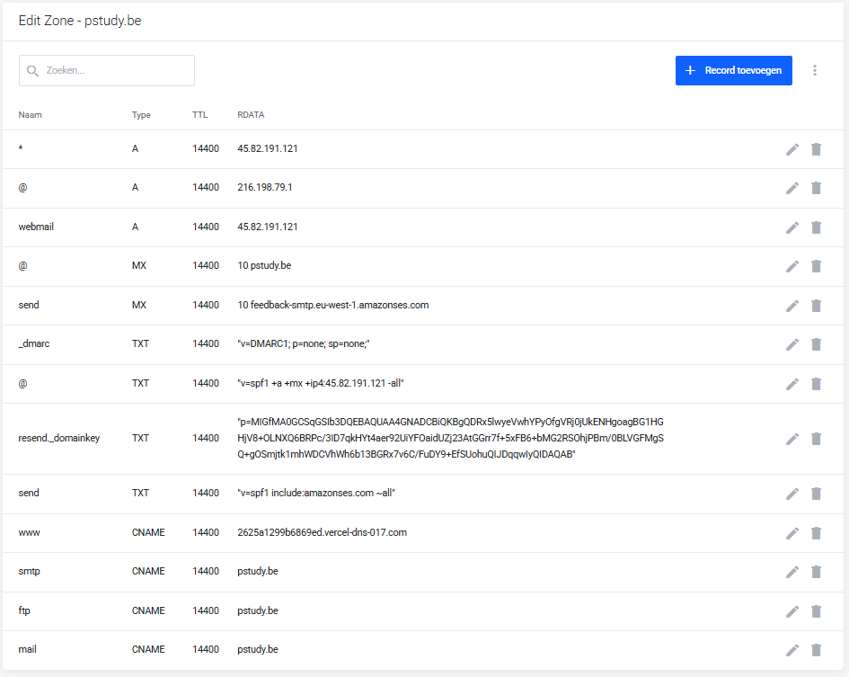

PS C:\pstudy-web> nslookup -type=A pstudy.be 1.1.1.1
Server: one.one.one.one
Address: 1.1.1.1

Non-authoritative answer:
Name: pstudy.be
Address: 216.198.79.1

PS C:\pstudy-web>

PS C:\pstudy-web> nslookup -type=A pstudy.be 8.8.8.8
Server: dns.google
Address: 8.8.8.8

Non-authoritative answer:
Name: pstudy.be
Address: 216.198.79.1

PS C:\pstudy-web>

